**Cleveland State University**   
**Monte Ahuja College of Business**   
**IST 614 – Project Management and Scheduling**

**Project Name:** Data Alignment and Enhancement for Semantic Segmentation

**Team Name:** Team Project -5

**Assignment Number:** MD 2 – Planning I

We, the undersigned team members, hereby solemnly pledge that the work assigned and submitted is completed solely by us and represents our own efforts and understanding of the in-depth knowledge acquired by us throughout this learning process.



**Deliverable Acceptance Form**

**Date:** 11/15/2023

**Project Name:** Data Alignment Project

**Deliverable Name:** Data Alignment Project Initiating

**Project Manager:** Yoga Sundaram

**Project Sponsor:** Chief Information Officer

**Acknowledgement and Acceptance:**

We, the undersigned, acknowledge and accept the delivery of the work completed for this deliverable on behalf of our organization. Our signature attests to my agreement that this deliverable has been completed. No further work should be done on this deliverable.

**1. Was this deliverable completed to your satisfaction?**

**[ ] Yes**

**[ ] No**

**2. Please provide the detailed reasons for your satisfaction or dissatisfaction for this deliverable:**

**3. If the deliverable is not acceptable, describe in detail what additional work must be done to complete it:**

**Contact’s signature for resubmission of deliverable if found unacceptable:**

**[Contact's Signature]**

**Team Contract**

**Project Name: Data Alignment Project**

**Project Team Members Names and Sign-off:**

|  |  |
| --- | --- |
| **Name** | **Sign-off on Team Contract** |
| **Yoga Sundaram** |  |
| **Akhil Dasari** |  |
| **Uttej Reddy Pateti** |  |
| **Phanendra Goud Palle** |  |

**Code of Conduct:** As a project team, we will:

* **Respect**: This principle emphasizes treating every team member with respect, regardless of their role or level of expertise. It sets the expectation that we will maintain a professional and courteous demeanor, valuing each individual's contributions and ideas.
* **Collaborate**: Collaboration is at the core of our team's success. We commit to working together harmoniously, pooling our knowledge, skills, and experiences to achieve our project goals effectively and efficiently. By embracing collaboration, we aim to leverage the collective strength of our team.
* **Transparency**: Transparency is vital for keeping the project on track. We pledge to maintain open and honest communication regarding the project's progress, challenges, and risks. By sharing this information transparently, we ensure that everyone is well-informed and can contribute to solving problems and making informed decisions.

**Participation:** We will:

* **Engagement:** Actively engage in project activities, discussions, and decisions, demonstrating a proactive attitude towards project success.
* **Expertise Sharing:** Share our unique skills, knowledge, and experiences that are relevant to the project's objectives to enhance the team's collective capabilities.
* **Flexibility:** Be flexible and adaptable to changes in project requirements, priorities, and timelines, ensuring that we can respond effectively to evolving circumstances.
* **Accountability**: Take ownership of our assigned tasks and responsibilities, ensuring that we deliver on our commitments and meet project goals.
* **Continuous Improvement**: Strive for ongoing personal and team improvement by seeking feedback, learning from experiences, and implementing best practices to enhance project performance.
* **Effective Communication**: Maintain clear and open communication with team members, promptly sharing relevant updates, challenges, and solutions to facilitate efficient collaboration.

**Communication:** We will:

1. **Open Communication:**

**1. Collection of Ideas:**

* Compose a symphony of ideas where every team member's voice is a unique instrument contributing to the overall melody.
* Harmonize our conversations, blending diverse perspectives into a beautiful and unified composition.

**2. Collaboration Canvas:**

* View each conversation as an empty canvas waiting for vibrant strokes of thoughts, concerns, and ideas.
* Use the palette of our team's diverse perspectives to create an exquisite masterpiece in every dialogue.
* Keep the canvas clean by erasing any traces of disrespectful communication.

1. **Timely Updates:**
2. **Project Papyrus:**

* Write our project's unfolding story on the ancient papyrus of weekly updates, crafting a narrative that includes progress, challenges, next steps, and pivotal decisions.
* Share these scrolls in the grand library of our shared team site, allowing our collective journey to be preserved for all to see.

1. **Update Gazette:**

* Publish a weekly gazette that captures the essence of our project's journey, complete with headlines about progress, challenges, breakthroughs, and critical decisions.
* Distribute these gazettes through the digital avenues of our team site, keeping everyone informed with style.

1. **Conflict Resolution:**

**1. Conflict Choreography:**

* **When conflict takes the stage, choreograph a graceful dance to navigate through the discord together.**
* **Enlist the guidance of a seasoned choreographer if our duet falters, ensuring a harmonious performance.**
* **Commit to resolving conflicts with the elegance and precision of a ballet, preserving the team's cohesion and camaraderie.**

**2. Resolution Canvas:**

* **Treat conflicts as an empty canvas where we can collaboratively paint resolutions that reflect the collective strokes of our creativity and understanding.**
* **If needed, call upon a skilled curator to help frame our conflicts into a masterpiece of agreement.**
* **Ensure that our conflict resolution process is a work of art that leaves our team's trust and respect intact.**

**Problem Solving:** We will:

* Early Identification: Proactively identify potential issues and risks in the project by regularly assessing our progress and the external environment. Early detection allows us to address challenges before they become major roadblocks.
* Collaborative Solutions: When issues arise, we will foster a collaborative approach to finding solutions. This involves leveraging the diverse skills and perspectives of our team members to develop effective and innovative solutions.
* Feedback Loop: Establish a feedback loop to ensure that solutions are effective and sustainable. We will monitor the outcomes of our problem-solving efforts and make adjustments as necessary to ensure long-term success.
* Continuous Improvement: View problems as opportunities for growth and learning. We commit to not only resolving issues but also continuously improving our processes and approaches based on the lessons learned from each challenge.
* Root Cause Analysis: Whenever possible, we will conduct thorough root cause analyses to understand the underlying factors contributing to problems. This analysis helps us address issues at their source rather than just addressing symptoms.
* Documentation and Knowledge Sharing: Maintain clear and comprehensive documentation of our problem-solving processes and outcomes. This documentation will be readily accessible to the team and serve as a valuable knowledge base for future projects.

**Meeting Guidelines:** We will:

* Agenda Preparation: Ensure that a clear and detailed agenda is prepared in advance of each meeting, outlining the topics, objectives, and expected outcomes.
* Punctuality: Start and end meetings on time to respect everyone's schedules and commitments.
* Active Participation: Encourage active participation from all team members, promoting an inclusive environment where everyone's input is valued.
* Focused Discussions: Stay on topic during meetings and avoid tangential discussions that may derail the agenda.
* Decision-Making Process: Clearly define the decision-making process, whether by consensus, vote, or another method, and ensure that it is followed consistently.
* Action Items: Assign action items with clear responsibilities and deadlines at the end of each meeting, ensuring accountability for follow-up tasks.
* Meetingx Records: Maintain accurate meeting minutes or records, documenting key discussions, decisions, and action items for future reference.
* Technology and Resources: Ensure that the necessary technology and resources, such as presentation materials or documents, are prepared and accessible for the meeting.
* Respectful Communication: Promote respectful and professional communication during meetings, encouraging constructive feedback and discouraging disrespectful behavior.
* Follow-up and Review: Conduct periodic reviews to assess the effectiveness of meetings and make necessary improvements to enhance productivity and collaboration.

**Data Alignment Project: Approval for Planning Document**

Prepared by: Yoga Sundaram, Akhil Dasari

Date: [15/11/2023]

Project Title: Data Alignment Project

Project Description: The Data Alignment Project aims to create a seamless data integration and alignment system that enhances the efficiency and accuracy of data processing within the organization.

Project Scope:

Development of a data alignment software system.

Implementation of scalable infrastructure to support data alignment.

Establishment of robust data security and user access control mechanisms.

Comprehensive training and support for end-users and administrators.

Goals and Objectives:

The primary objective of the Data Alignment Project is to implement a system or a tool that ensures accurate and timely Alignment of semantic segmentation results, i.e., accurate real-time data that reflects in the metadata and the backend system. By doing so, AWS aims to fortify its capabilities in the field of computer vision and provide customers with a seamless, high-quality experience and products.

Key Deliverables:

* Data Alignment Software
* Scalable Infrastructure Setup
* User Access Control System
* Cost Estimate and Cost baseline
* Project Documentation

Estimated Budget: $514,000

Project Timeline: 319 days

Expected ROI: 126%

Project Management:

Project Manager: [Yoga Sundaram]

Business Analyst: [Uttej Reddy Pateti]

Data Analyst: [Akhil Dasari]

Systems Architect: [Phanendra Goud Palle]

Key Milestones:

Project Kickoff: November 1st 2022

Completion of Design Phase: August 3rd 2023

Software Development Completion: November 10th 2023

Testing Phase Commencement: December 10th 2023

Project Go-Live: January 17th 2024

Proposed Signatures: 

I hereby approve the initiation of the planning phase for the Data Alignment Project based on the information provided in this document.

CIO /Project Sponsor Signature: ___< Rick Dalzell> Date: __November 15th 2023___________

Project Manager Signature: Date: _November 15th 2023_____

**SCOPE STATEMENT**

**Project Justification: Data Alignment Project**

Overview:

The Data Alignment Project emerges from a critical need within Amazon Web Services (AWS) to address fundamental challenges in the field of computer vision, specifically within the semantic segmentation process. Semantic segmentation plays a pivotal role in enhancing the accuracy of object detection and classification, contributing to the development of machine learning algorithms powering AWS products, particularly the Alexa devices.

Business Need:

In the expansive realm of cloud computing, AWS is a global leader committed to delivering cutting-edge services to organizations of all sizes. The Data Alignment Project is rooted in the imperative need to overcome existing challenges within the Image and Video Annotation (IVA) team, where data misalignment with metadata and backend records has been identified as a persistent issue. This misalignment adversely impacts data quality, usability, and operational efficiency, hindering the seamless integration of semantic segmentation results into the AWS ecosystem.

Impact on Productivity:

The current data misalignment leads to inconsistencies in employee productivity tracking, creating manual overheads in calculating contributions. The inefficiency in data alignment results in usability concerns, false identifications by machine learning algorithms, and inefficient manual reconciliation processes, placing a strain on human resources. This misalignment directly affects the Science team's ability to effectively train machine learning algorithms, impacting the overall quality of data used for algorithm training and, consequently, the performance of AWS products.

Competitive Advantage:

Addressing the data alignment challenge is not just a necessity but a strategic move for AWS. Successfully aligning data will yield improved data quality, ensuring reliable services for data analysts, scientists, annotators, and end-users. This enhancement in data quality positions AWS with a competitive advantage, offering more reliable and efficient services compared to competitors in the cloud computing market.

Alignment with Organizational Goals:

The Data Alignment Project aligns seamlessly with AWS's commitment to technological excellence and customer satisfaction. The project's success will contribute to the enhancement of AWS's computer vision capabilities, fostering innovation and maintaining AWS's position as a global leader in cloud computing.

Product Characteristics and Requirements:

1. Data Accuracy Enhancement:

Characteristic: The system's commitment to elevating data accuracy extends beyond mere alignment; it strives to establish a paradigm where the aligned data reflects the true essence of semantic segmentation outputs.

Requirement: The alignment process is meticulously engineered to not just meet but exceed industry standards, aiming for a reduction in data discrepancies of less than 2% across all data categories. This stringent requirement underscores the system's dedication to providing impeccably accurate data, forming the backbone of reliable decision-making within the AWS ecosystem.

2. Data Integration Efficiency:

Characteristic: The system's prowess in data integration is not solely about streamlining; it's a strategic initiative to transform the way AWS handles data, fostering efficiency and agility throughout the integration processes.

Requirement: The targeted reduction of at least half in the time required for data integration is a pivotal benchmark. This requirement doesn't just signify efficiency gains; it represents a fundamental shift toward real-time data utilization. By achieving this, the system empowers AWS services with the ability to adapt swiftly to changing data landscapes, ensuring that the insights derived are both timely and impactful.

3. Scalability:

Characteristic: Scalability isn't merely a technical attribute; it's a forward-looking philosophy embedded in the system's architecture. It anticipates the growth trajectory of data generated through semantic segmentation, positioning the AWS ecosystem for sustained success.

Requirement: The system's scalability is stress-tested to handle a projected 20% increase in data volume without any compromise in performance. This requirement isn't just a numerical benchmark; it reflects the system's resilience and adaptability, ensuring that as AWS services expand, the system effortlessly accommodates the surge in data demands.

4. Data Security:

Characteristic: Beyond encryption, data security is woven into the system's DNA. It's a comprehensive approach that safeguards not just the data itself but also the trust placed in AWS by its users.

Requirement: The system goes beyond the standard; it enforces end-to-end encryption during both transmission and storage, strictly adhering to AWS data security standards. This requirement sets a gold standard for data protection, ensuring that aligned data remains confidential, integral, and fortified against any potential threats.

5. User Access Control:

Characteristic: User access control is more than a feature; it's a governance mechanism that empowers administrators to craft a nuanced and secure data access environment.

Requirement: Administrators wield a robust system that enables them to define, refine, and manage user roles with precision. This requirement isn't just about restricting access; it's about providing administrators with a fine-grained toolkit, allowing them to align data access with the specific needs of different user roles within the AWS ecosystem.

6. Scalable Infrastructure:

Characteristic: Scalable infrastructure isn't a reactive measure; it's a strategic imperative. The system's infrastructure is architected with foresight, ensuring that it not only adapts to increased workloads but also serves as a catalyst for provisioning additional AWS resources seamlessly.

Requirement: The infrastructure's capability to accommodate increased workloads is complemented by its innate ability to provision additional AWS resources dynamically. This requirement isn't just about handling peaks in demand; it's about empowering the AWS ecosystem with a scalable foundation that propels growth and innovation.

7. Data Availability:

Characteristic: Data availability transcends mere uptime; it's a commitment to providing users with uninterrupted access to aligned data, fostering a continuous and reliable data-driven experience.

Requirement: The system's commitment is reflected in its mandate for aligned data to be available 24/7, with a minimum uptime of 98%. This requirement is more than a service level agreement; it's a testament to the system's reliability and its unwavering dedication to supporting AWS services with consistent, always-accessible, and accurate data.

**Summary of Project Deliverables:**

Project Management-Related Deliverables:

1. Business Case: The "Business Case" document outlines the critical need for the "Data Alignment Project." It delves into the challenges faced by the AWS Tools Team in semantic segmentation, emphasizing the importance of accurate data alignment. The document provides a comprehensive justification for the project, addressing issues such as data inconsistencies, productivity challenges, and the impact on machine learning algorithm training for Alexa devices.
2. Project Charter: The "Project Charter" formally authorizes the "Data Alignment Project," defining its objectives, scope, stakeholders, and overall approach. It serves as a guiding document, aligning the project with AWS's strategic goals and emphasizing the commitment to delivering high-quality services to customers.
3. Team Contract: The "Team Contract" establishes clear roles, responsibilities, and expectations for each team member involved in the "Data Alignment Project." It promotes collaboration, accountability, and effective communication within the project team, fostering a positive and productive working environment.
4. Scope Statement: The "Scope Statement" provides a detailed articulation of the "Data Alignment Project." It outlines project objectives, deliverables, constraints, and acceptance criteria, ensuring a shared understanding among stakeholders about the project's scope and intended outcomes.
5. Work Breakdown Structure (WBS): The "WBS" breaks down the "Data Alignment Project" into manageable tasks, facilitating effective project management and resource allocation. It organizes the project into phases such as planning, analysis, design, and implementation, each with its set of tasks.
6. Schedule: The "Schedule" establishes a timeline for the "Data Alignment Project," specifying start and end dates for each task. It ensures that the project progresses efficiently and adheres to the planned timelines.
7. Cost Baseline: The "Cost Baseline" provides a detailed estimate of project costs for the "Data Alignment Project." It includes expenses related to development, testing, deployment, software, hardware, and services, serving as a reference for financial management throughout the project.
8. Status Reports: "Status Reports" are regular updates on project progress, milestones achieved, and any deviations from the original plan. These reports keep stakeholders informed and allow for timely adjustments to ensure project success.
9. Final Project Presentation: The "Final Project Presentation" is a culmination of the "Data Alignment Project," summarizing key achievements, challenges, and lessons learned. It provides stakeholders with a comprehensive overview of the project's outcomes.
10. Final Project Report: The "Final Project Report" is a comprehensive documentation of the entire "Data Alignment Project," including outcomes, challenges, and recommendations for future projects. It serves as a valuable reference for future initiatives.
11. Lessons-Learned Report: The "Lessons-Learned Report" reflects on the successes and challenges of the "Data Alignment Project." It provides insights for continuous improvement in future projects, capturing valuable knowledge and experience gained during the project.

**Product-Related Deliverables:**

1. Research Reports: "Research Reports" are comprehensive documents presenting in-depth findings from the analysis of existing data alignment methods, corrective technologies, and best practices. These reports serve as a knowledge base, guiding the project team in making informed decisions throughout the "Data Alignment Project." They also provide reference material for ongoing research in the field.
2. Design Documents: "Design Documents" are detailed blueprints outlining the technical architecture, data flow diagrams, and specifications for the data alignment solution. These documents serve as a guide for the development team, ensuring a systematic and organized approach to implementing the solution. They act as a reference for understanding the system's structure and functionality.
3. Software Code: The "Software Code" is the heart of the "Data Alignment Project." It includes the actual codebase developed to implement the data alignment solution. The code incorporates algorithms, logic, and configurations required for accurate real-time alignment of data generated through semantic segmentation. The software code represents the culmination of the project's development efforts.
4. Hardware: "Hardware" encompasses any physical components or infrastructure required to support the data alignment solution. This may involve specialized hardware designed or procured to enhance the project's capabilities. Hardware considerations ensure that the implemented solution operates seamlessly within the AWS ecosystem, contributing to the overall success of the project.
5. Testing and Quality Assurance Report: The "Testing and Quality Assurance Report" documents the testing processes undertaken to validate the functionality and performance of the data alignment solution. It includes details on test cases, test results, and any issues identified during the testing phase. This report ensures that the implemented solution meets the specified requirements and adheres to quality standards.
6. Deployment Strategy: The "Deployment Strategy" outlines the plan for deploying the data alignment solution into the AWS ecosystem. It includes steps for transitioning from development to production, ensuring a smooth integration process. The deployment strategy addresses potential challenges and risks associated with the implementation, providing a roadmap for a successful launch.
7. Licensing Agreement: The "Licensing Agreement" formalizes the terms and conditions for the use of the data alignment solution. This legal document defines how the solution can be utilized, distributed, and accessed by end-users. A clear licensing agreement ensures compliance with intellectual property rights and establishes a framework for the solution's usage.

**Project Success Criteria:**

1. Accurate Data Generation: Successful alignment of data generated through semantic segmentation within the AWS ecosystem, ensuring accurate recording of employee working hours and the smooth flow of processed data to the Science team.
2. Improved Data Accuracy and Consistency: Demonstration of improved data accuracy and consistency, minimizing discrepancies and errors in the aligned data categories. The alignment process should reduce data discrepancies by at least less than 2% for all data categories.
3. Streamlined Data Integration Processes: Achievement of streamlined data integration processes within the AWS ecosystem. The time required for data integration should be reduced by at least half compared to the current process, enhancing operational efficiency.
4. Enhanced Usability of Data: Successful implementation leading to enhanced usability of data for analysis and decision-making within AWS. Teams and users should experience improved accessibility and efficiency in retrieving and utilizing aligned data.
5. Effective User Access Control: Implementation of a robust user access control system, providing role-based access to aligned data. Administrators should be able to define and manage user roles, limiting access to specific data categories as needed, contributing to data security.
6. Scalable Infrastructure: Design and implementation of a scalable infrastructure capable of accommodating an increasing volume of data generated through semantic segmentation. The system should handle a 20% increase in data volume without degradation in performance, ensuring scalability.
7. High Availability of Aligned Data: Ensuring a high availability of aligned data, with aligned data accessible 24/7 and a minimum uptime of 98%. This criterion ensures continuous access to critical data for users within the AWS ecosystem.

**WBS Flow Chart**

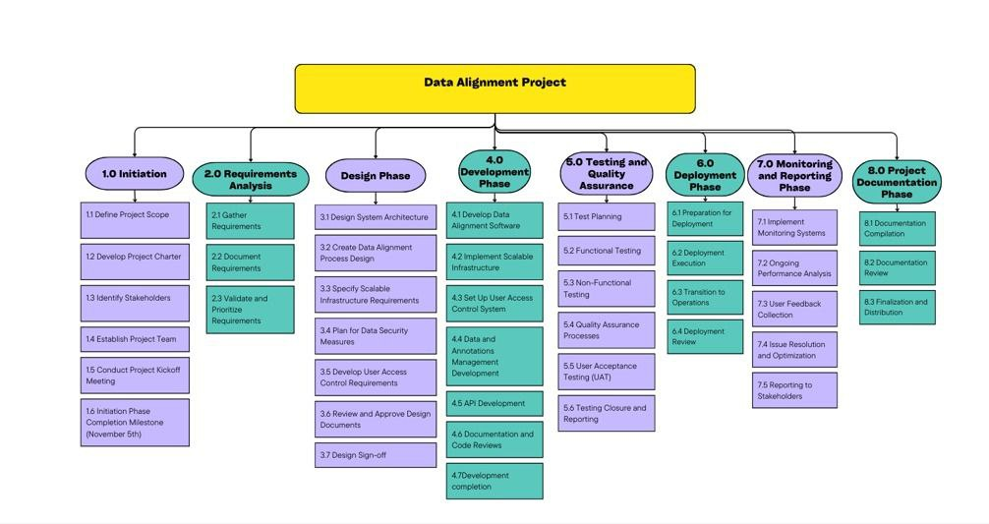

**Gantt Chart:**

**Network Diagram**

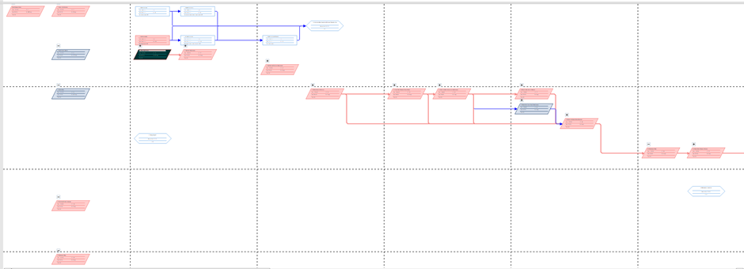

**WBS Dictionary**

|  |  |  |  |  |
| --- | --- | --- | --- | --- |
| **Element Name** | **Phase** | **Index Number** | **WBS Element Description** | **Deliverables** |
| 1. Project Initialization | Project Initialization | 1 | Define Project Scope- Outline the project's boundaries, objectives, and deliverables to ensure a shared understanding among stakeholders and team members. | Scope Statement Document |
|  |  | 1.1 | Develop Project Charter- Create a document that formally authorizes the project, provides the project manager with the authority to apply organizational resources to project activities, and documents initial requirements that satisfy stakeholder needs and expectations. | Project Charter Document |
|  |  | 1.2 | Identify Stakeholders- Identify all parties affected by the project, as well as their interests, influence, and impact on project success. | Stakeholder Register |
|  |  | 1.3 | Establish Project Team- Assemble the group of individuals who will work on the project, defining roles and responsibilities | Team Roster |
|  |  | 1.4 | Conduct Project Kick-off Meeting- Conduct an initial meeting with project stakeholders and team members to review the project scope, objectives, and expectations, and to formally start the project. | Kick-off Meeting Agenda and Minutes |
|  |  | 1.5 | Initiation Phase Completion Milestone (November 5th)- Mark the completion of the project initiation phase and transition to the project planning phase. | Initiation Phase Review Report |
| 2. Requirements Analysis | Requirements Analysis | 2 | Gather Requirements- : Collection of detailed project requirements through various elicitation techniques such as interviews, workshops, and surveys. | Requirement Gathering Report |
|  |  | 2.1 | Conduct Stakeholder Interviews - Engage with stakeholders through interviews to gather their specific needs and expectations. | Stakeholder Interview Schedule- Interview Questions- Documented Stakeholder Requirements |
|  |  | 2.1.1 | Identify and schedule interviews with stakeholders | Schedule for Stakeholder Interviews |
|  |  | 2.1.1.1 | Prepare interview questions | Prepared Interview Questionnaire |
|  |  | 2.1.1.2 | Document stakeholder requirements | Documented Stakeholder Requirements |
|  |  | 2.1.2 | Facilitate Requirements Workshops- Interactive sessions with stakeholders to collaboratively identify requirements and expectations. | Workshop Schedule- SWOT Analysis Summary- Ideas Collected  through Brainstorming |
|  |  | 2.1.2.1 | Organize cross-functional workshops | Schedule for Cross-functional Workshops |
|  |  | 2.1.2.2 | Conduct SWOT analysis to understand system needs | Summary Report on SWOT Analysis |
|  |  | 2.1.2.3 | Use brainstorming techniques to gather ideas | Ideas Compilation Report |
|  |  | 2.1.3 | Distribute and Analyze Surveys - Distribution of surveys to a broader audience to gather a wider range of requirements and insights. | Survey Questionnaire- Survey Results Analysis |
|  |  | 2.1.3.1 | Develop survey questions | Developed Survey Questionnaire |
|  |  | 2.1.3.2 | Distribute surveys to a broader audience | Distributed Survey to Audience |
|  |  | 2.1.3.3 | Compile and analyze survey results | Analysis Report on Survey Results |
|  |  | 2.1.4 | Observe Annotator Workflows -  On-the-ground observation of annotators' current processes to identify potential areas for improvement and refinement in the system design. | Documented Data Annotation Processess- Identified Inefficiencies and Improvement Areas- Requirements for Tool Enhancements |
|  |  | 2.1.4.1 | Document current data annotation processes | Documented Annotation Processes |
|  |  | 2.1.4.2 | Identify inefficiencies and areas for improvement | Identified Inefficiencies and Improvement Areas |
|  |  | 2.1.4.3 | Gather requirements for tool enhancements | Requirements for Tool Enhancements |
|  |  | 2.2 | Document Requirements - Formal documentation of all the requirements gathered into a structured and detailed requirements document. | Documented Requirements |
|  |  | 2.3 | Validate and Prioritize Requirements - Validation of the documented requirements with stakeholders and prioritization based on the project's objectives and constraints. | Validated and Prioritized Requirements |
| 3.0 Design Phase | Design Phase | 3 | Design System Architecture - Develop a scalable and secure architecture that meets the requirements of the data alignment project. | System Architecture Design Document |
|  |  | 3.1 | Create Data Alignment Process Design - Design the algorithms and processes for aligning data within the system. | Data Alignment Process Design |
|  |  | 3.2 | Specify Scalable Infrastructure Requirements - Define the infrastructure needs to support scalability and performance of the data alignment system. | Specification Document for Infrastructure Needs |
|  |  | 3.3 | Plan for Data Security Measures - Establish security protocols and disaster recovery plans to protect data integrity and availability. | Data Security Plan |
|  |  | 3.4 | Develop User Access Control Requirements- Create a comprehensive access control system to manage user permissions and authentication. | User Access Control Requirements Document |
|  |  | 3.5 | Review and Approve Design Documents - Conduct thorough reviews of all design documents and obtain formal approval from stakeholders. | Approved Design Documents |
| 4.Development Phase | Development | 4 | The phase dedicated to the creation and implementation of crucial components necessary for the Data Alignment project. This involves translating the outlined requirements into functional systems and structures. | Development Efforts |
|  |  | 4.1 | Focused efforts on creating the software architecture, coding, testing, and debugging to ensure the data alignment software meets specified requirements. | Developed Data Alignment Software |
|  |  | 4.2 | Execution of plans to establish a scalable infrastructure, ensuring that the system can handle increased data volumes and adapt to future growth. | Implemented Scalable Infrastructure |
|  |  | 4.3 | Creation and setup of a robust user access control system to manage and regulate user permissions and data accessibility within the system. | Established User Access Control System |
|  |  | 4.4 | Development work on managing data and annotations efficiently, including structuring data storage, organization, and retrieval mechanisms. | Developed Data and Annotations Management |
|  |  | 4.5 | Development and testing of Application Programming Interfaces (APIs) necessary for system integrations and interactions with external systems or users. | Developed and Tested APIs |
|  |  | 4.6 | Documentation of the entire development process and thorough code reviews to ensure adherence to coding standards and identify potential issues. | Comprehensive Documentation and Code Review Reports |
| 5. Testing and Quality Assurance | Testing and Quality Assurance | 5 | This phase focuses on ensuring the robustness, reliability, and compliance of the developed systems through diverse testing methodologies and quality control measures. | Comprehensive Testing Reports |
|  |  | 5.1 | Test Planning | Detailed Test Strategy and Plan Document |
|  |  | 5.1.1 | Develop Test Strategy | Define the scope, objectives, and focus of testing efforts, select appropriate testing tools and frameworks, Identify testing metrics and success criteria |
|  |  | 5.1.2 | Prepare Test Plan Document | Document detailing test phases, schedules, resources, roles, responsibilities, and stakeholder-approved test plan |
|  |  | 5.2 | Functional Testing | Verified Functionality of the System |
|  |  | 5.2.1 | Unit Testing | Individual components tested independently |
|  |  | 5.2.2 | Integration Testing | Integrated components tested for interactions |
|  |  | 5.2.3 | System Testing | Entire system tested as a whole |
|  |  | 5.3 | Non-Functional Testing | Verified non-functional aspects of the system |
|  |  | 5.3.1 | Performance Testing | System performance under various conditions tested |
|  |  | 5.3.2 | Security Testing | System's security measures tested |
|  |  | 5.3.2.1 | Conduct vulnerability assessments and penetration testing | Identified vulnerabilities and ensured security measures |
|  |  | 5.3.2.2 | Check compliance with security policies and regulations | Compliance with security standards ensured |
|  |  | 5.3.2.3 | Implement fixes for security issues | Addressed and resolved security issues |
|  |  | 5.3.3 | Usability Testing | System's usability and user experience tested |
|  |  | 5.3.3.1 | Test the user interface for intuitiveness and ease of use | User interface intuitiveness assessed |
|  |  | 5.3.3.2 | Gather user feedback to identify UX improvements | Collected user feedback for UX improvements |
|  |  | 5.3.3.3 | Refine UI/UX based on testing outcomes | Implemented UI/UX improvements based on feedback |
|  |  | 5.4 | Quality Assurance Processes | Ensured adherence to quality standards and continuous improvement |
|  |  | 5.4.1 | QA Review Meetings | Meeting minutes and plans for quality improvement |
|  |  | 5.4.1.1 | Conduct regular meetings to review testing progress | Progress review minutes and plans for improvement |
|  |  | 5.4.1.2 | Evaluate adherence to quality standards | Reports on adherence to quality standards |
|  |  | 5.4.1.3 | Plan for quality improvement initiatives | Improvement initiatives planned and implemented |
|  |  | 5.4.2 | Defect Management | Identified, tracked, and resolved defects |
|  |  | 5.4.2.1 | Track and prioritize discovered defects | Prioritized defect reports |
|  |  | 5.4.2.2 | Assign defects to relevant development teams for resolution | Assigned defects for resolution and team notifications |
|  |  | 5.4.2.3 | Re-test and close defects upon resolution | Closed and resolved defects |
|  |  | 5.5 | User Acceptance Testing (UAT) | End-user approval and satisfaction with the system |
|  |  | 5.5.1 | UAT Planning | Criteria and environment prepared for UAT |
|  |  | 5.5.1.1 | Collaborate with stakeholders to define UAT criteria | Defined UAT criteria and sessions scheduled |
|  |  | 5.5.1.2 | Prepare UAT environment and data sets | UAT environment setup and data prepared |
|  |  | 5.5.1.3 | Schedule UAT sessions with end-users | UAT sessions scheduled and conducted |
|  |  | 5.5.2 | UAT Execution | Feedback collected and system adjusted based on UAT |
|  |  | 5.5.2.1 | Facilitate UAT sessions and gather user feedback | UAT feedback collected and documented |
|  |  | 5.5.2.2 | Document UAT results and user experience insights | UAT reports and insights documented and shared |
|  |  | 5.5.2.3 | Adjust system functionalities based on UAT feedback | System adjusted and improved based on UAT feedback |
|  |  | 5.6 | Testing Closure and Reporting | Comprehensive testing reports and closure activities |
|  |  | 5.6.1 | Compile Testing Reports | Summarized reports on testing outcomes |
|  |  | 5.6.2 | Test Closure Activities | Activities and processes for concluding testing phases |
| 6.Deployment Phase | Deployment Phase | 6 | The phase focused on preparing, executing, and reviewing the deployment process to transition the developed solution into the operational environment. | Successfully Deployed System |
|  |  | 6.1 | Preparation for Deployment- This involves finalizing the deployment plan, setting up the production environment, and verifying its readiness. | Deployment plan finalized, Production environment set up, and verified. |
|  |  | 6.1.1 | Finalize Deployment Plan | Comprehensive deployment plan |
|  |  | 6.1.2 | Set up the Production Environment | Established production environment |
|  |  | 6.1.3 | Verify the Production Environment | Confirmed and validated production environment |
|  |  | 6.2 | Deployment Execution - Deploying software components, monitoring the deployment process, and conducting post-deployment testing. | Software components deployed, Deployment process monitored, and post-deployment testing conducted |
|  |  | 6.2.1 | Deploy Software Components | Successfully deployed software components |
|  |  | 6.2.2 | Monitor Deployment Process | Continuous monitoring of the deployment process |
|  |  | 6.2.3 | Post-deployment Testing | Testing conducted after deployment to ensure functionality |
|  |  | 6.3 | Transition to Operations- Training end-users and administrators, updating system documentation, and handing over the system to support teams. | End-users and administrators trained, System documentation updated, and handover to support teams |
|  |  | 6.3.1 | Train End-Users and Administrators | End-users and administrators trained for system usage |
|  |  | 6.3.2 | Update System Documentation | Updated system documentation reflecting changes |
|  |  | 6.3.3 | Handover to Support Teams | System handed over to support teams for ongoing maintenance |
|  |  | 6.4 | Deployment Review- Collecting deployment metrics, conducting a retrospective of the deployment process, and confirming alignment with project objectives. | Deployment metrics collected, Deployment retrospective conducted, and project alignment confirmed |
|  |  | 6.4.1 | Collect Deployment Metrics | Metrics and data collected during the deployment |
|  |  | 6.4.2 | Conduct Deployment Retrospective | Review of the deployment process and outcomes |
|  |  | 6.4.3 | Confirm Project Alignment | Verification of project alignment with objectives |
| 7. Monitoring and Reporting Phase | Monitoring and Reporting Phase | 7 | This phase focuses on implementing monitoring systems, collecting user feedback, resolving issues, and generating reports to ensure continuous system performance and stakeholder communication. | Established Monitoring Systems and Reports |
|  |  | 7.1 | Implement Monitoring Systems- This involves setting up performance metrics, monitoring tools, and configuring alerts for system monitoring. | Performance metrics established, Monitoring tools set up, and Alerts configured |
|  |  | 7.1.1 | Establish Performance Metrics | Defined and established key performance metrics |
|  |  | 7.1.2 | Set Up Monitoring Tools | Installed and configured monitoring tools |
|  |  | 7.1.3 | Configure Alerts and Notifications | Alerts and notifications configured for monitoring |
|  |  | 7.2 | Ongoing Performance Analysis - Conducting regular system audits, analyzing system logs, and reporting performance trends. | Regular system audits conducted, System logs analyzed, and Performance trends reported |
|  |  | 7.2.1 | Conduct Regular System Audits | Scheduled and executed system audits |
|  |  | 7.2.2 | Analyze System Logs | System logs systematically analyzed |
|  |  | 7.2.3 | Report Performance Trends | Reports generated on performance trends |
|  |  | 7.3 | User Feedback Collection - Implementing mechanisms for collecting and integrating user feedback into reporting. | Implemented mechanisms for collecting user feedback |
|  |  | 7.3.1 | Implement User Feedback Mechanisms | Feedback mechanisms implemented for users |
|  |  | 7.3.2 | Review User Feedback | Collected user feedback reviewed |
|  |  | 7.3.3 | Integrate Feedback into Reporting | Feedback integrated into regular reporting |
|  |  | 7.4 | Issue Resolution and Optimization- Prioritizing reported issues, updating the system based on findings, and communicating resolutions. | Reported issues triaged, System updated based on findings, and Resolutions communicated |
|  |  | 7.4.1 | Triage Reported Issues | Reported issues prioritized and categorized |
|  |  | 7.4.2 | Update System Based on Findings | System updates implemented based on findings |
|  |  | 7.4.3 | Communicate Resolutions | Resolutions communicated to stakeholders |
|  |  | 7.5 | Reporting to Stakeholders - Preparing regular status reports, conducting stakeholder meetings, and adjusting project plans based on reporting. | Regular status reports prepared, Stakeholder meetings conducted, and Project plans adjusted |
|  |  | 7.5.1 | Prepare Regular Status Reports | Detailed reports on system status |
|  |  | 7.5.2 | Conduct Stakeholder Meetings | Meetings held to discuss system performance |
|  |  | 7.5.3 | Adjust Project Plans Based on Reporting | Project plans adjusted based on reporting |
| 8.Project Documentation Phase | Project Documentation Phase | 8 | This phase revolves around compiling, reviewing, finalizing, and distributing project documentation to ensure completeness, accuracy, and accessibility of project information. | Compiled and Distributed Project Documentation |
|  |  | 8.1 | Documentation Compilation- Assembling technical and user documentation to encompass all project-related information. | Technical and User Documentation assembled |
|  |  | 8.1.1 | Assemble Technical Documentation | Technical documentation compiled |
|  |  | 8.1.2 | Assemble User Documentation | User documentation compiled |
|  |  | 8.2 | Documentation Review- Reviewing both internal and stakeholder-specific documentation to ensure accuracy and completeness. | Internal and stakeholder documentation reviewed |
|  |  | 82.1 | Internal Documentation Review | Review of internal documentation |
|  |  | 8.2.2 | Stakeholder Documentation Review | Review of documentation by stakeholders |
|  |  | 8.3 | Finalization and Distribution- Finalizing edits, versioning, publishing documentation, and archiving project records. | Final edits, versioning, publication, and archiving of project records |
|  |  | 8.3.1 | Final Edits and Versioning | Final editing, version control, and updating documentation |
|  |  | 8.3.2 | Publish Documentation | Published project documentation |
|  |  | 8.3.3 | Archive Project Records | Archived project records for future reference |

**Resource Sheet**

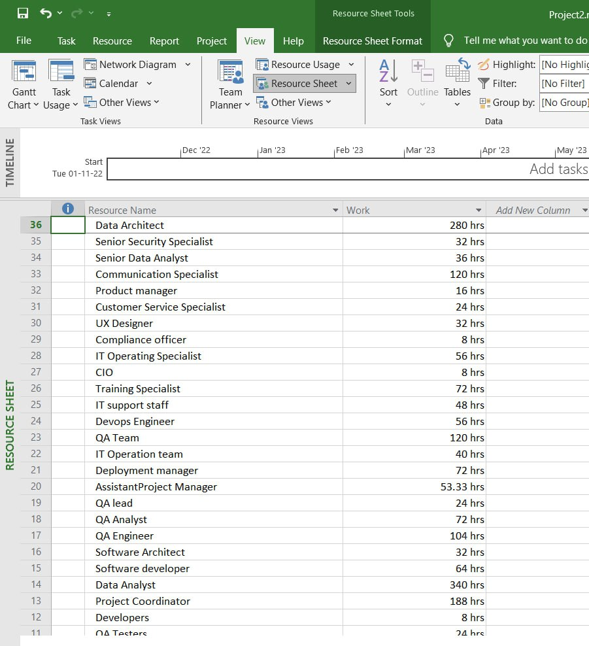

Please refer MS project file attached for WBS Resource Sheet, Network Diagram and Gantt Chart. We assign resource(s) to each applicable task in the Gantt chart and Used the “predecessors” also included dependencies.

**Mile stone and deliverables**

|  |  |  |
| --- | --- | --- |
| **Phase** | **Milestone Description** | **Deliverables** |
| Project Initialization | Project Charter Approval | Approved Project Charter |
| Project Initialization | Team and Stakeholder Alignment | Stakeholder Register, Team Contracts |
| Project Initialization | Kickoff Meeting Completion | Kickoff Meeting Summary, Initial Project Plan |
| 2. Requirements Analysis | Requirements Gathering Completion | Gathered Requirements Document |
| 2. Requirements Analysis | Requirements Documentation | Requirements Specification Document |
| Requirements Analysis | Requirements Validation | Prioritized Requirements List |
| **DESIGN** | System Architecture Design Approval | System Architecture Plan |
| 3. Design Phase | Data Alignment Process Design Completion | Data Alignment Process Design Document |
| . Design Phase | Security and Infrastructure Design Completion | Security Plan, Infrastructure Requirement Document |
| . Design Phase | User Access Control Requirement Specification | User Access Control Specification Document |
| . Design Phase | Design Phase Sign-off | Design Sign-off Document |
| **IMPLEMENTATION** | Development Phase Kickoff | Development Kickoff Document |
| 4. Development Phase | Core Development Completion | Data Alignment Software Module, API Endpoints |
| 4. Development Phase | Internal Review and Code Sign-off | Code Review Report, Development Completion Document |
| 5. Testing and Quality Assurance | Testing Plan Approval | Approved Test Plan |
| . Testing and Quality Assurance | Completion of Functional Testing | Functional Test Report |
| . Testing and Quality Assurance | Completion of Non-Functional Testing | Performance Test Report |
| . Testing and Quality Assurance | UAT Sign-off | User Acceptance Test Report |
| . Testing and Quality Assurance | Testing Phase Closure | Testing Closure Report, Test Sign-off |
| 6. Deployment Phase | Deployment Readiness | Deployment Readiness Review Document |
| Deployment Phase | Go-Live | Deployment Execution Report, Go-Live Checklist |
| Deployment Phase | Operational Handover | Operational Transition Document, Training Records |
| Deployment Phase | Deployment Phase Sign-off | Deployment Sign-off Document |
| 7. Monitoring and Reporting Phase | Monitoring Systems Operational | Monitoring Setup Confirmation Document |
| 7. Monitoring and Reporting Phase | Initial Performance Review | Initial Performance Analysis Report |
| 7. Monitoring and Reporting Phase | Feedback Integration | Feedback Summary Document, Feedback Integration Plan |
| 7. Monitoring and Reporting Phase | Quarterly Stakeholder Report | Quarterly Project Performance Report |
| 8. Project Documentation Phase | Documentation Package Compilation | Compiled Project Documentation Package |
|  | Documentation Review Completion | Reviewed and Approved Documentation |
|  | Project Closure | Final Project Closure Document, Lessons Learned, Archive Confirmation |

**Mile Stone and Deliverable:**

|  |  |
| --- | --- |
| **Phase/Deliverable** | **Date/Time** |
| Business Case | November 1st, 2022 |
| Scope Statement | November 7th, 2022 |
| Project Charter | November 14th, 2022 |
| Work Breakdown Structure (WBS) | November 22nd ,2022 |
| Schedule | November 25th ,2022 |
| Final Project Report | January 24th 2024 |
| Lessons- Learned Report | January 24th 2024 |

**Activity list and Activity Attribute**

|  |  |  |  |  |
| --- | --- | --- | --- | --- |
| **Phase** | **Activity Attribute** | **Resources** | **Responsibilities** | **Deliverables** |
| **Planning** |  |  |  |  |
| Project Initialization | Define Project Scope | Project Manager (Yoga Sundaram) | Defining the project boundaries and deliverables | Scope Document |
| Project Initialization | Develop Project Charter | Project Manager (Yoga Sundaram) | Creating a document that formally authorizes the project | Project Charter |
| Project Initialization | Identify Stakeholders | Business Analyst (Uttej Reddy Pateti) | Identifying all parties interested in or affected by the project | Stakeholder Register |
| Project Initialization | Establish Project Team | Project Manager (Yoga Sundaram) | Assembling the team necessary to complete the project | Team Roster |
| Project Initialization | Conduct Project Kickoff Meeting | Project Manager (Yoga Sundaram) | Organizing an initial meeting to communicate the start of the project | Kickoff Meeting Summary |
| Project Initialization | Initiation Phase Completion Milestone | - | Marking the completion of the project initiation phase | Milestone Completion |
| **ANALYSIS** |  |  |  |  |
| 2. Requirements Analysis | Gather Requirements | Business Analyst (Uttej Reddy Pateti) | Collecting detailed information on what the project must achieve | Requirements Specification |
| 2. Requirements Analysis | Document Requirements | Systems Analyst | Documenting the functional and non-functional requirements | Requirements Document |
| 2. Requirements Analysis | Validate and Prioritize Requirements | Project Manager (Yoga Sundaram) | Assessing and ranking requirements based on project goals | Prioritized Requirements List |
| **DESIGN** |  |  |  |  |
| Design Phase | Design System Architecture | Systems Architect ( Phanendra Goud Palle) | Outlining the system's technical framework | System Architecture Plan |
|  | Create Data Alignment Process Design | Process Analyst | Designing the process for aligning data | Process Design Document |
|  | Specify Scalable Infrastructure Requirements | Infrastructure Architect | Defining infrastructure needs for scalability | Infrastructure Plan |
|  | Plan for Data Security Measures | Security Specialist | Establishing security protocols and measures | Security Plan |
|  | Develop User Access Control Requirements | Security Analyst | Specifying access control mechanisms | Access Control Specifications |
|  | Review and Approve Design Documents | Project Manager (Yoga Sundaram), QA Lead | Reviewing design documents and obtaining approval | Design Document Approval |
|  | Design Sign-off | - | Finalizing and approving the design phase | Sign-off Document |
| 4. Development Phase |  |  |  |  |
|  | Develop Data Alignment Software | Development Team | Coding and developing the data alignment software | Software Module |
|  | Implement Scalable Infrastructure | Infrastructure Team | Setting up and configuring the infrastructure | Implemented Infrastructure |
|  | Set Up User Access Control System | Security Team | Implementing the access control system | User Access Control System |
|  | Data and Annotations Management Development | Data Engineer | Creating systems for managing data annotations | Annotation Management System |
|  | API Development | Software Developer | Developing APIs for data alignment integration | API Endpoints |
|  | Documentation and Code Reviews | Technical Writer, QA Lead | Documenting the development process and reviewing code | Technical Documentation, Code Review Report |
|  | Development Completion | - | Marking the end of the development phase | Development Completion Sign-off |
| 5. Testing and Quality Assurance |  |  |  |  |
|  | Test Planning | QA Lead | Planning the testing activities and defining scope and objectives | Test Plan |
|  | Functional Testing | QA Team | Testing individual functions of the software | Functional Test Report |
|  | Non-Functional Testing | QA Team | Testing the software against non-functional parameters like performance | Performance Test Report |
|  | Quality Assurance Processes | QA Lead | Continuous monitoring and improvement of the QA process | QA Reports |
|  | User Acceptance Testing (UAT) | UAT Participants | Conducting final testing with end-users | UAT Report |
|  | Testing Closure and Reporting | QA Lead | Concluding the testing phase and documenting the outcomes | Testing Closure Report |
|  | Test Closure Activities | - | Completing all testing activities | Test Closure Sign-off |
| IMPLEMENTATION |  |  |  |  |
| 6. Deployment Phase | Preparation for Deployment | Deployment Manager | Preparing for the software deployment | Deployment Plan |
|  | Deployment Execution | IT Operations Team | Carrying out the deployment activities | Deployment Report |
|  | Transition to Operations | Training Specialist | Training users and transitioning to operational status | Operational Transition Plan |
|  | Deployment Review | Project Manager (Yoga Sundaram) | Reviewing the deployment process and outcomes | Deployment Review Report |
| 7. Monitoring and Reporting Phase |  |  |  |  |
|  | Implement Monitoring Systems | IT Support Staff | Implementing systems to monitor project performance | Monitoring System Setup |
|  | Ongoing Performance Analysis | Data Analyst (Akhil Dasari) | Continuously analyzing system performance | Performance Analysis Reports |
|  | User Feedback Collection | Customer Service Specialist | Gathering and analyzing user feedback | Feedback Reports |
|  | Issue Resolution and Optimization | IT Support Staff | Addressing and optimizing any issues | Issue Resolution Report |
|  | Reporting to Stakeholders | Project Manager (Yoga Sundaram) | Reporting the project status to stakeholders | Stakeholder Reports |
| 8. Project Documentation Phase |  |  |  |  |
|  | Documentation Compilation | Technical Writer | Compiling all project-related documentation | Compiled Documentation |
|  | Documentation Review | Project Manager (Yoga Sundaram), Stakeholders | Reviewing and approving project documentation | Reviewed Documentation |
|  | Finalization and Distribution | Project Coordinator | Finalizing and distributing documentation | Final Project Documentation |

**Activity Attribute**

|  |  |  |
| --- | --- | --- |
| **Name** | **Team Role** | **Responsibilities** |
| **Yoga Sundaram** | Project Manager | Oversees the project, coordinating teams, managing resources, and ensuring alignment with goals while mitigating risks. |
| **Uttej Reddy Pateti** | Business Analyst | Business Analyst delves into business needs, gathering and documenting requirements for the project, ensuring solutions align with objectives. |
| **Akhil Dasari** | Data Analyst | Data Analyst collects, analyzes, and validates data, providing insights crucial for decision-making |
| **Phanendra Goud Palle** | Systems Architect | Systems Architect designs the system's structure, selects technologies, and ensures seamless integration for optimal performance. |

**Product-related deliverables:**

1. The actual data alignment solution, including the software, algorithms, and configurations developed to align data from various sources within the AWS ecosystem.

2. Detailed design documents that with specificity of the architecture along with data flow diagrams, and technical specifications of the data alignment solution.

3. Reports on research findings related to the Data alignment methods, corrective technologies, and best practices, this serves as reference materials for the project.

4. Data Alignment Algorithm

5. Software Code and configuration for the Data Alignment

6. Hardware

7. Testing and Quality assurance report with the manual

8. Deployment Strategy

9. Licensing agreement

**Cost Estimation & Cost Baseline**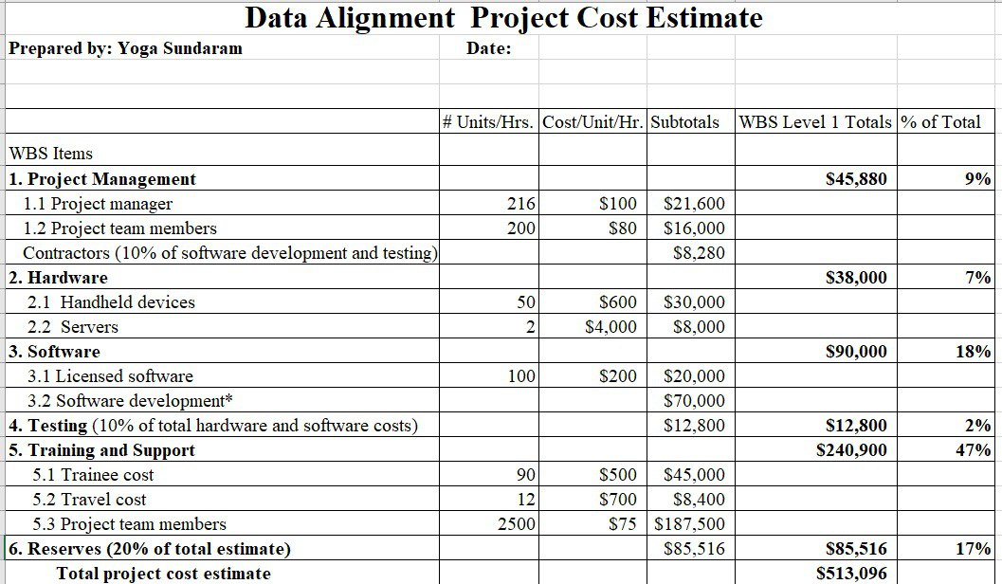

**Cost Baseline: $296,873**

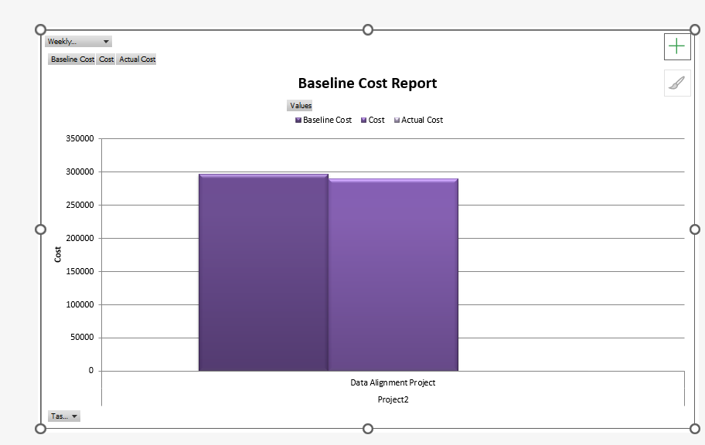

**Cost Estimate**

The project management component is expected to cost $45,880 in total, accounting for 9% of the whole budget. This comprises the project manager and team members, as well as a percentage set aside for software development and testing contractors.

* Hardware costs $38,000, or 7% of the overall cost, and includes portable devices and servers.
* Software expenditures, including licensing and development costs, amount $90,000, accounting for 18% of the budget.
* Testing is determined to be 10% of the total hardware and software expenditures, or $12,800, or 2% of the total budget.
* Training and support are the most major expenditures, accounting for $240,900 (47% of the total expected cost). This category comprises trainee expenditures, travel expenses, and project team member compensation.
* A reserve fund of $85,516 represents 17% of the overall budget and is 20% of the total projection.

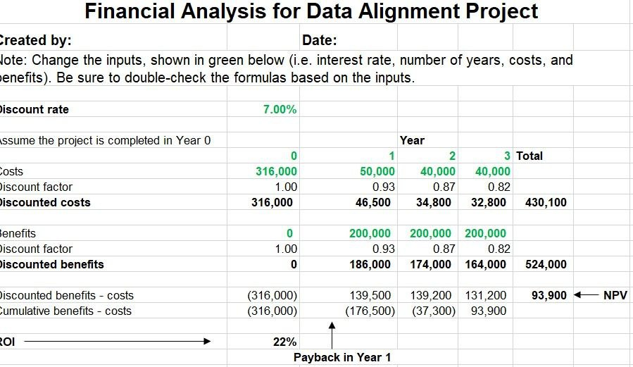

The project starts with an initial investment of $316,000 in Year 0, resulting in a negative NPV of -$316,000. In Year 1, the project incurs costs of $46,500 and generates benefits of $186,000, resulting in a positive NPV of $139,500. This positive NPV continues to accumulate over the years, reaching a cumulative NPV of $93,900 by Year 3. The project has a positive cumulative NPV, indicating that it is expected to be financially viable and generate a positive return on investment (ROI). The ROI is calculated as the cumulative NPV divided by the initial investment, which in this case is 22%.